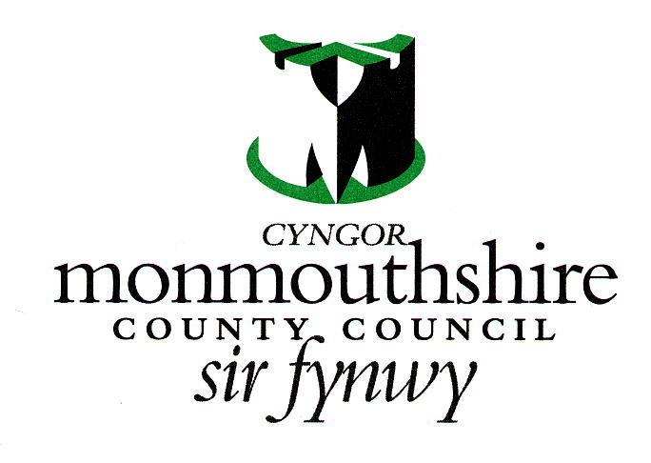

MONMOUTHSHIRE COUNTY COUNCIL APPLICATION TO RESERVE GRAVE SPACE

I wish to apply to reserve a full grave space/cremated remains space (please delete as applicable) in Llanfoist/Llanelly/Chepstow/Monmouth Cemetery (please delete as applicable)

Applicant Name……………………………………………………………………………………………………………………………………….

Applicant address………………………………………………………………………………………………………………………………..

……………………………………………………………………………………………………………………………………………………………

If applying on behalf of person(s) under age 18:

Name of Beneficiary ……………………………………………………………………………………………………………………………….

Address of Beneficiary…………………………………………………………………………………………………………………………….

Date of Birth of Beneficiary…………………………………………………………………………………………………………………….

RESERVATION IS FOR A PERIOD OF 5 YEARS.
TO RETAIN THE RESERVATION, RENEWAL (AT NO EXTRA CHARGE) WILL BE REQUIRED WITHIN ONE MONTH AFTER EXPIRY DATE

I UNDERSTAND THAT IF THE DECEASED RESERVED A PLOT WHILST RESIDING OUTSIDE OF MONMOUTHSHIRE, AN OUT OF COUNTY CHARGE WILL ALSO BE APPLIED AT THE TIME OF INTERMENT IF THE DECEASED’S LAST KNOWN ADDRESS IS OUTSIDE MONMOUTHSHIRE, AS PER CURRENT RULES.
Eg. 2018-19 charges - new single depth interment in county £1250, out of county £2500, Cremated Remains interment in county £925, out of county £1850

DATA PRIVACY SUMMARY NOTICE
How we will use your information
Processing of your personal data by Monmouthshire County Council (MCC) is necessary to comply with the Local Governments Act 1972 and the Local Authorities Cemeteries Order 1977. Without this information, the MCC Cemeteries Service may not be able to carry out the request to reserve a grave space.
Your details will be legitimately shared with the Funeral Director and Memorial Mason where necessary in a safe and secure manner. From time to time it may also be necessary to share details of a burial with members of the public. Your personal details will not be shared further, unless in relation to safeguarding or other legal obligations.
Your records will be safely stored and retained in line with our retention policy, unless we need to retain under another lawful basis.
You have a number of rights in relation to the information including the right of access to information we hold about you and the right to complain if you are unhappy with the way your information is being processed. For further information on how we process your information and your rights please visit www.monmouthshire.gov.uk/home/data-protection
Should you need to make a complaint about the way your data has been processed, please contact dataprotection@monmouthshire.go.uk or if you are not fully satisfied you may contact the Information Commissioner’s Office online at www.ico.org.uk/concerns or via their helpline: 0303 123 1113

Signature ………………………………………………………………………………………………..Date…………./…………../……………..

