People Services




Gender Pay Gap Report 2018

Contents

Introduction | 3
What do we have to report? | 3
Workforce Profile | 4
Bonus Pay | 5
Quartile Pay Bands | 5
Conclusions | 5
Factors affecting the Gender Pay Gap | 6
What we have done | 6

Introduction

The Gender Pay Gap Information Regulations require all employers with 250 or more employees to report their Gender Pay Gap annually, publishing on a national Government website as well as the organisations website. The Gender Pay Gap Information Regulations apply to employers in the public and private sector.
In addition to these new regulations, employers in the public sector are subject to a specific public sector equality duty in respect of their functions - The Equality Act 2010 (Specific Duties and Public Authorities) Regulations 2017.
The regulations apply to all employers with 250 or more employees on the "snapshot" date. The "snapshot" date for the public sector is 31 March each year. Therefore, the Council is required to publish its gender pay gap for each year on the Monmouthshire County Council website and on the Government website (GOV.UK), no later than 31 March of the following year. Therefore, for the “snapshot” date of 31 March 2017, the findings must be published no later than 31 March 2018.
The purpose of Gender Pay Gap reporting is to achieve greater gender equality across the UK and increase pay transparency. In 2016 the Office for National Statistics put the overall gender pay gap for all employees in the UK at a median of 18.1% .The gender pay gap is an analysis of gender distribution across the workforce.
Monmouthshire County Council is committed to the principle of equal pay for all employees by ensuring that it meets the requirements of the Equality Act. To achieve this the Council introduced Single Status and uses the Greater London Provincial Council (GLPC) job evaluation scheme to assess the value of all National Joint Council (NJC) jobs across the organisation, which provides evidence in support of the banding of each job within our grading structure. Salaries are paid according to band and incremental annual progression within the band occurs irrespective of an employee's gender.

What do we have to report?
The regulations require employers to publish the following information:
- The mean gender pay gap;
- The median gender pay gap;
- The mean bonus pay gap;
- The median bonus pay gap;
- The relative proportions of male and female employees in each quartile pay band.

Workforce Profile
As of the ‘snapshot date’ of 31 March 2017 the Councils workforce profile was as follows:
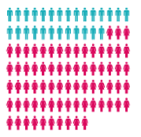
Male 27% Female 73%

The Full Time and Part Time gender ratios was:
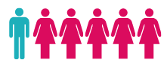


Part Time 5:1 Full Time 1.3:1

Mean Gender Pay Gap



8.5%

£16.57 £1.42 £15.15

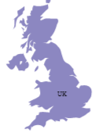
Median Gender Pay Gap
2016 18.1%

11.5%
£15.05 £1.73 £13.32

Bonus Pay
Monmouthshire County Council has not operated any bonus schemes since 2009 - upon the introduction of Single Status.

Bonus Pay Gap 0%

Quartile Pay Bands

Lower Pay Quartile  £0 - £19,929 | Lower Middle Pay Quartile  £19,930 - £26,142
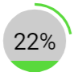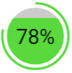 | 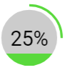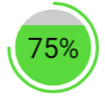
Upper Middle Pay Quartile  £26,142 - £36,868 | Upper Quartile  £36,869 - £106,915
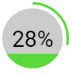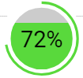 | 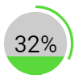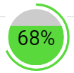

Conclusions
The Mean Gender Pay Gap for all workers at 31 March 2017 was 8.5% a difference of £1.42 per hour.
The Median Pay Gap for all workers at 31 March 2017 was 11.5% some way below the 2016 ONS survey, which was 18.1%
Quartile Analysis shows, that in all Quartiles there is a relatively stable proportion of female to male as you would expect based on the overall proportion of workers being 27% male to 73% female. The proportion of males to females increases through the quartiles.

Factors affecting the Gender Pay Gap
The pay gap is strongly affected by the makeup of the Council’s workforce and its distribution.
The majority of the Council’s staff are in the lower grades, this means that the overall pay gap is distorted, reflecting workforce composition rather than pay inequalities. This is particularly evident in Cleaning, Catering and Social Care, which has a large female workforce who in general terms work more part time hours, as opposed to roles dominated by males in areas such as Highways, Waste and Landscape who tend to work full time hours. Therefore, the Gender Pay Gap is as much a societal gap as a pure pay gap.
The Council has a very stable workforce and at the time of the report had a low turnover rate at 7.89% - this means that there are only a few vacancies that give an opportunity for changes in the makeup of the workforce.

What we have done
Monmouthshire County Council is committed to equality in the workplace having already taken several measures to ensure that it is a fair and equitable employer by:
- Ensuring equal pay for work of equal value using job evaluation.
- Adoption of the Living Wage, which is paid to all employees at the lower level of the pay structure. This aims to help to reduce the effects of poverty. Monmouthshire County Council introduced the Living Wage in April 2014. Monmouthshire County Council is not accredited for the Living Wage, and it is optional for it to apply any Living Wage pay increases when they arise. The Council increased the Living Wage in April 2018 to the national level (£8.75 per hour). Payment for the Living Wage is paid as an additional amount to an employee’s grade.

- Promoting and supporting a number of flexible working policies for all employees within the organisation, irrespective of gender. These include job share, part time working and, term time working. In some areas, there is also a flexibility, under agile working, to work from different locations.
The Council is therefore confident that its gender pay gap does not stem from paying male and female employees differently for the same or equivalent work. Rather its gender pay gap is the result of the roles in which male and females work within the Council and the salaries that these roles attract.

