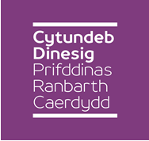
Cardiff Capital Region City Deal
Joint Cabinet
Friday 17th March 2017, 10.00 a.m.
Ty Dysgu, Nantgarw

Agenda

- Chairperson
To elect a Chairperson for the meeting

- Welcome and Apologies for Absence
To receive any apologies for absence

- Declarations of Interest
To be made at the start of the Agenda Item in question, in accordance with the members Code of Conduct

- Report on the Accountable Body Arrangements
To receive the Report of the City of Cardiff Council Corporate Director of services - attached

- Report on the Transition Plan 2017/18
(tasks and activities)
To receive the Report of the Cardiff Capital Region Programme Director -attached
- Report on the Terms of Reference for the Programme Board
To receive the Report of the Cardiff capital Region Programme Director
-attached

Sheila Davies
CCR Programme Director
13 March 2017

