
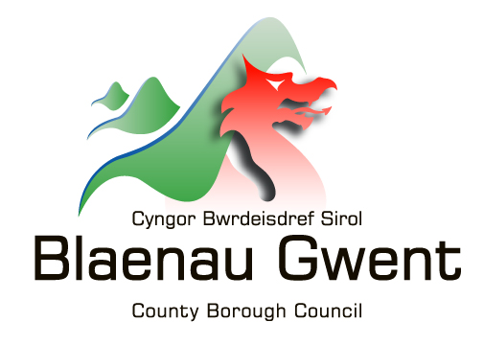


MONMOUTHSHIRE FARM SCHOOL ENDOWMENT TRUST FUND

Academic Year…………………………………

Please send your completed application form to: CYP Finance, Monmouthshire Council, P O Box 106 Caldicot. NP26 9AN

Section A Personal Details

Title:………………………………….. Marital Status:…………………………..…..

Surname:…………………………….. Forename:………………………………..….

Date of Birth:………………………… Age:………Household Income…………….

Full Address:…………………………………………………………………………….….

………………………………………………………………………………………………..

……………………………………………………………………………………………..…

Post Code………………………. Telephone No:………………………………

Email Address:…………………………………………………………………………..…

Bank sort Code………………………… Account Number……………………………

How long have you been resident in the Greater Gwent area?

Section B Course Details

Full title of course:………………………………………………………………….……..

Institution/College/University:………………………………………………….………...

Course duration:………………………. Current Year:……………….……………..

Full time / Part time Hours per week:…………. Fees: £........…………………
(delete as appropriate)

I will be residing during the course: At home In College

Section C Declaration

In consideration of Monmouthshire Local Authority paying me a grant, I hereby promise to refund the Authority on demand any overpayment of grant which may be made, however arising, except an overpayment made under a mistake of law.

I give consent for Monmouthshire Local Authority to obtain further information from other Local Authorities to support this application.

I understand that my information will be shared with trustees of the fund in order to assess any award which may be made.

Signature of Student:………………………………Date:……………………….

Section D Other financial Assistance

Have you made any applications for the following student support:

1) Education Maintenance Allowance (EMA) Y / N
If yes please state the amount you have been awarded

2)
Assembly Learning Grant (ALG/FE) Y / N
If yes please state the amount you have been awarded

3)
Higher Education Loans/ Grants Y / N
If yes please state the amount you have been awarded

4) Any other grants/ awards, please give details: Y / N

£…………....... Per……………………

£…………....... Per……………………

£…………....... Per……………………

Section E Details of Assistance required

Please be as specific as possible. Detail the maximum amount you are likely to incur as a result of studying this course.

Description Amount £

Course Fees £………………

Books/Stationery £………………

Travel (delete as appropriate) £………………..

Car / Public Transport

Specialist Equipment/Clothing £………………
Please list:
………………………
………………………
………………………

Other course related costs £………………
Please list:
………………………
………………………
………………………

Education

Present Qualifications:

……………………………………………………………………………………………………………………………………………...

Last Educational Establishment:

………………………………………………………………………………………………

Period Attended:

………………………………………………

Monmouthshire Farm School Endowment Trust Fund

In order to be eligible for an award from this Trust Fund, you will need to meet each of the following criteria:

1) Be living in the area of benefit:
Torfaen, Monmouthshire, Blaenau Gwent, Caerphilly
(as defined on the map overleaf – County of Monmouthshire as it was in 1956)
2) Be attending Coleg Gwent, Usk Campus or any other college or university as a student of agriculture or related subjects.
Ie, Agriculture studies, veterinary studies, equine studies, forestry, blacksmithing course. Etc

All questions of the application form must be answered, ‘N/A’ or ‘Nil’ must be stated where applicable.

Section A – Personal details
- Please ensure that you provide your full permanent postal address and bank details. All reimbursements will be made directly to your bank account upon production of valid receipts.
- Please supply approximate annual household income.

Section B – Course details
- Full title of your course should include the name of the course and the qualification
- Please identify whether the course is full time or part time as this could influence any award made.
- It is important to tick the relevant box for living at home or in college accommodation as this can also influence any award made.

Section C – Declaration
- No application will be presented to the Governors of the Trust if the declaration is not signed and dated.

Section D – Other financial assistance
- It is very important to declare any other sources of income relating to your course. Failure to declare this may result in no award being made.
- If you are aged between 16 and 18 years of age, studying full time you may be eligible for Education Maintenance Allowance (EMA).
- If you are aged 19 years or over, studying a Further Education course full time or part time, you may be eligible for an Assembly Learning Grant (ALG/FE).
- If you are studying a Higher Education course full time or part time, you may be eligible for Student loans and grants.
For more information: www.studentfinancewales.co.uk

Section E – Assistance required
- If you do not stipulate what costs you are likely to incur you will not be awarded any assistance.
- Please provide as much detail as possible to help the Governors of the Trust to make their decision in allocating awards.



