Industrial Unit to Let
7B Old Pill Farm Ind Est, Portskewett, Monmouthshire,
NP26 5JH
1059 sqft (98.42 sqm)

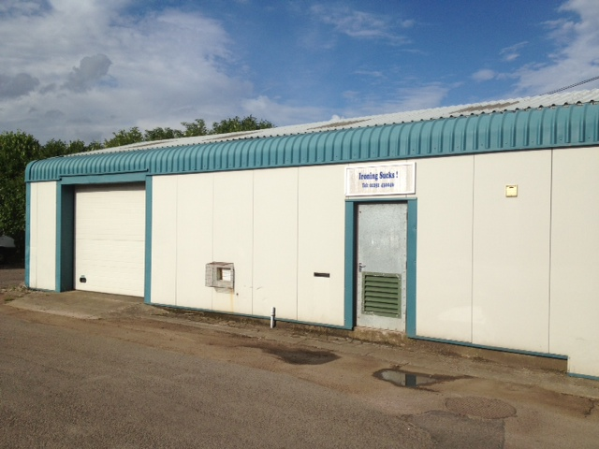

Location
The property is located in the Portskewett area of south Monmouthshire and is close to Severn Bridge Industrial Estate. It benefits from good transport links to the M48 motorway (J.2) and A48 trunk roads.

Accommodation
Gross internal area (including WC, warehouse) 1059 sqft (98.4 sqm). The unit benefits from access via a standard pedestrian entrance door and a roller shutter door measuring 2.5m
by 2.5m. The unit has a minimum eaves height of 3m. Parking in available onsite.

Rent
Offers invited in the region of £6,000 per annum (£500 per month) exclusive of all other outgoings.

Tenure

The property is available on a new lease, on effective full repairing and insuring terms.

Business Rates

Rateable Value: £3,650 p/a
Rates Payable 2015/16: £1,773.90 per annum. Small business relief is available for qualifying tenants. Applicants are advised to make their own enquires with the Business Rates department on 01633 644 644.

Energy Performance Certificate Available on request.

Legal Costs
Each party is to bear their own legal costs.

Viewings and further information
By prior appointment with Nicola Howells; 01633 748 338 or nicolahowells@monmouthshire.gov.uk


