Monmouthshire County Council
CCTV Scheme
Annual Review and Report

July 2016

At 1.30pm Friday 15th July 2016, the annual review of the Monmouthshire County Council (MCC) CCTV Scheme was conducted at County Hall, The Rhadyr, USK.
Attendees were:
Sharran Lloyd – Public Service Board Manager
Andrew Mason – ASB & CCTV Coordinator
Parmjit Sandhu – SRS, Torfaen CBC
The Annual Review was held in compliance with the requirements of the Information Commissioners CCTV Code of Practice, Surveillance Camera Commissioners Code of Practice and pursuant of the principles of Quality Management. It should be stated from the outset that Monmouthshire County Council, in partnership with the four Town Councils, are responsible for the Public Space CCTV in their county towns, however, the monitoring and associated responsibilities of the Control Room are shared with SRS in Torfaen CBC (TCBC).
The agenda subjects and associated outputs are recorded below:

1. Review of scheme objectives including any policy changes:
1.1 The objectives and policy of the scheme remain subject to continuous scrutiny and where appropriate review. TCBC hold the NSI Silver Standard.
1.2 The purpose of the MCC CCTV Scheme remains unchanged and appropriate.

2. Changes in the scheme boundaries and camera numbers / positions:
2.1 The scheme boundaries remain unchanged.
2.2 MCC has provided funding to maintain the programme of replacing BT Lines with Radio Link Technology, allowing a flexible service delivery and budgetary savings.
2.3 This year saw the replacing of the old cameras on the Usk Bridge with High Definition cameras and a radio link system which sends the images into Usk Police Station where the images are recorded.
2.4 A list of current cameras was presented to the meeting and agreed. The list will be appended to this Annual Report for the Information Commissioners (Appendix 1)
2.5 MCC and the four towns, Monmouth, Abergavenny, Caldicot and Chepstow continue with the Memorandum of Understanding with regards to operation and financial contribution of the scheme.
2.6 MCC and Torfaen SRS and Gwent Police continue with the Memorandum of Understanding with regards to storage of information in the Evidence Locker and Police access to the CCTV Control Room.
2.7 SRS had to repair of one of PSN recorders in 2015.

3. Review of the preferred suppliers list and current contracts
3.1 SRS have a Framework Supplier contracted to meet their demands selected in strict accordance with Torfaen Procurement Procedures and Standing Orders.

4. Review of the Data Protection Act and relevant legislation/codes of practice
4.1 There have been no significant changes under this subject heading.
4.2 Monmouthshire CCTV are to review the forms used for Data Access requests but continue to use the 4 forms:
- Internal Management for Monmouthshire Requests
- Internal Monmouthshire Requests for CCTV – Criminal Prosecutions
- Third Party Request
- Data Subject access Request

4.3 All requests under Freedom of Information are now channelled through Monmouthshire County Council Information Officer.

4.4 Monmouthshire CCTV is currently reviewing its Code of Practice and Procedure Manuals due to the introduction of the Surveillance Camera Commission Code of Practice.

4.5 Monmouthshire has a Privacy Impact Assessment form (Appendix 2) in place and PIA’s will be implemented shortly and all cameras assessed in accordance with Information Commissioners Office and DPA guidance.

4.6 New camera installations have had PIA’s carried out.

5. Maintenance schedule and results of performance testing
5.1 The maintenance of the CCTV System remains with the Framework contractor. The front end and back end are covered in two separate contracts.

5.2 The Synectics Synergy Pro operating and management system is working and is reviewed periodically.

6. Annual report and supporting statistics
6.1 The criteria agreed for reporting of statistics remains the same as previous years (Appendix 3).

7. Election of board members/scheme partners
Not Applicable

8. Review of complaints
8.1 There were no complaints recorded by the scheme within the review period.

9. Review of audit results, internal and external, to include verification of corrective actions and
analysis for preventative action:
9.1 Audit undertaken in line with MCC Standards.

9.2 Copies of the log sheets are available for inspection. An example of such auditing is the analysis of data from the Synectics digital system, which highlights the operation of CCTV cameras by the CCTV operators, recording the numbers of incidents both reported and monitored by them and requests for assistance from the Gwent Police. (Appendix 4).

10. Review of outstanding issues from minutes of management meetings
10.1 MCC CCTV User Group meets three times a year to overview CCTV in the four towns and the outcomes of the meetings held are circulated to all Torfaen CCTV staff and other interested parties by way of email.

11. Review of staff levels and recruitment needs
11.1 All recruiting of staff is dealt with by SRS.

12. Review of training needs
12.1 All staff trained to the required standard for the SIA licence and all staff is in possession of an SIA Licence.

12.2 All staff training needs and requirement are dealt with Torfaen CBC.

13. Any other business

The next annual review would be scheduled for May 2017.

Minutes Agreed By: S. Lloyd (MCC) Date: 15th July 2016

Minutes Agreed By: P. Sandhu (SRS) Date: 15th July 2016

Appendix 1
Camera locations.
Camera Number | Camera Location
77 | Castle St, Abergavenny
78 | High Street/Neville St, Abergavenny
79 | Cross Street – Angel Hotel, Abergavenny
80 | Frogmore Street, Abergavenny
81 | Fairfield Car Park, Abergavenny
82 | Bus Station Entrance, Abergavenny
201 | St Mary’s – Bus Station, Abergavenny
202 | High St / Market St, Abergavenny
RDU | St Faiths Close, Abergavenny
RDU | St Faiths Close – Gypsy Lane, Abergavenny
RDU | St Andrews Crescent, Abergavenny
83 | Sandy Lane, Caldicot
84 | Newport Road, Caldicot
85 | West End, Caldicot
86 | Jubilee Way Car Park, Caldicot
87 | Woodstock Way, Caldicot
88 | Town Centre, Caldicot
RDU | Oakley Way, Caldicot
89 | Thomas Street, Chepstow
90 | Moor Street, Chepstow
91 | High Street, Chepstow
92 | Nelson Street Car Park, Chepstow
93 | Beaufort Square, Chepstow
94 | Bulwark Road, Chepstow
95 | Welsh Street, Chepstow
199 | Welsh Street Car Park, Chepstow
200 | Library Manor Way, Chepstow
RDU | MCC Car Park Social Club, Chepstow
193 | Church Street, Monmouth
194 | Blestium Street, Monmouth
195 | Monnow Street –Pelican Crossing, Monmouth
196 | Monnow Street – Upper, Monmouth
197 | Monnow Street – Lower, Monmouth
198 | Agincourt Square – Shire Hall, Monmouth
203 | Agincourt Square – Iceland, Monmouth
RDU | Chaucer Way, Osbaston, Monmouth
RDU | Carbonne Close, Overmonnow, Monmouth
RDU | Highfield Road, Osbaston, Monmouth
Highways | Woodside, Usk
Highways | Cardiff Arms, Usk
Leisure | Chepstow Library
Leisure | Caldicot Castle

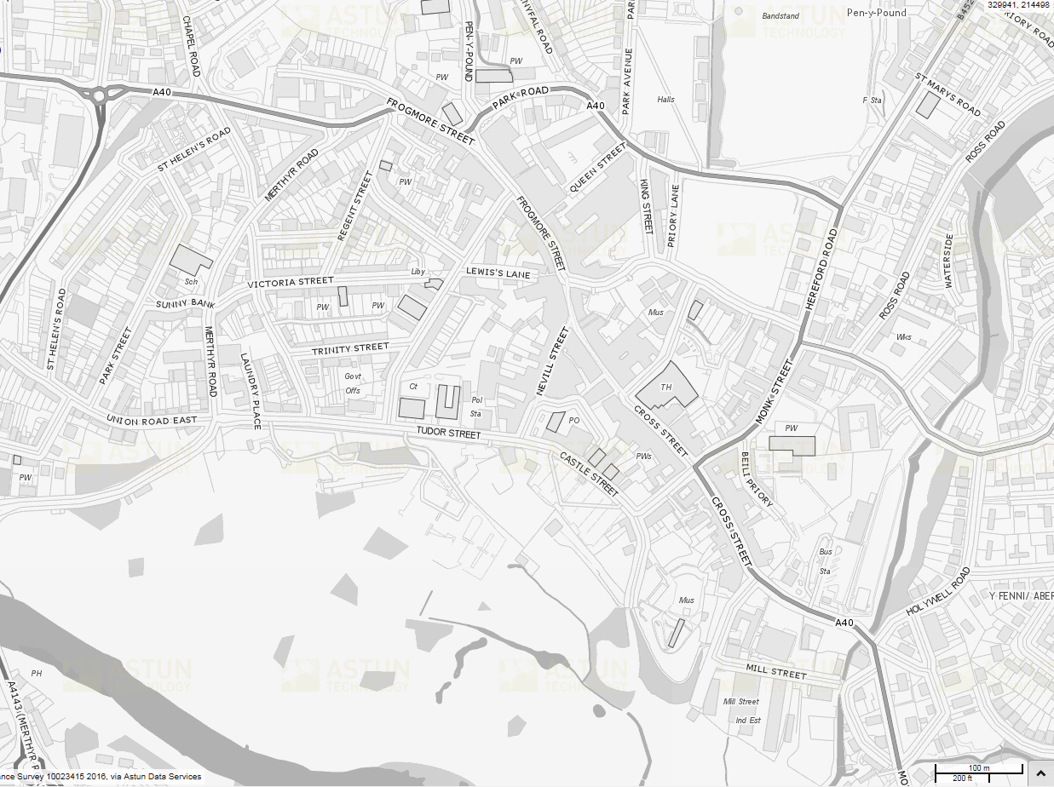
ABERGAVENNY
80
81
77
79
78
82
201
202
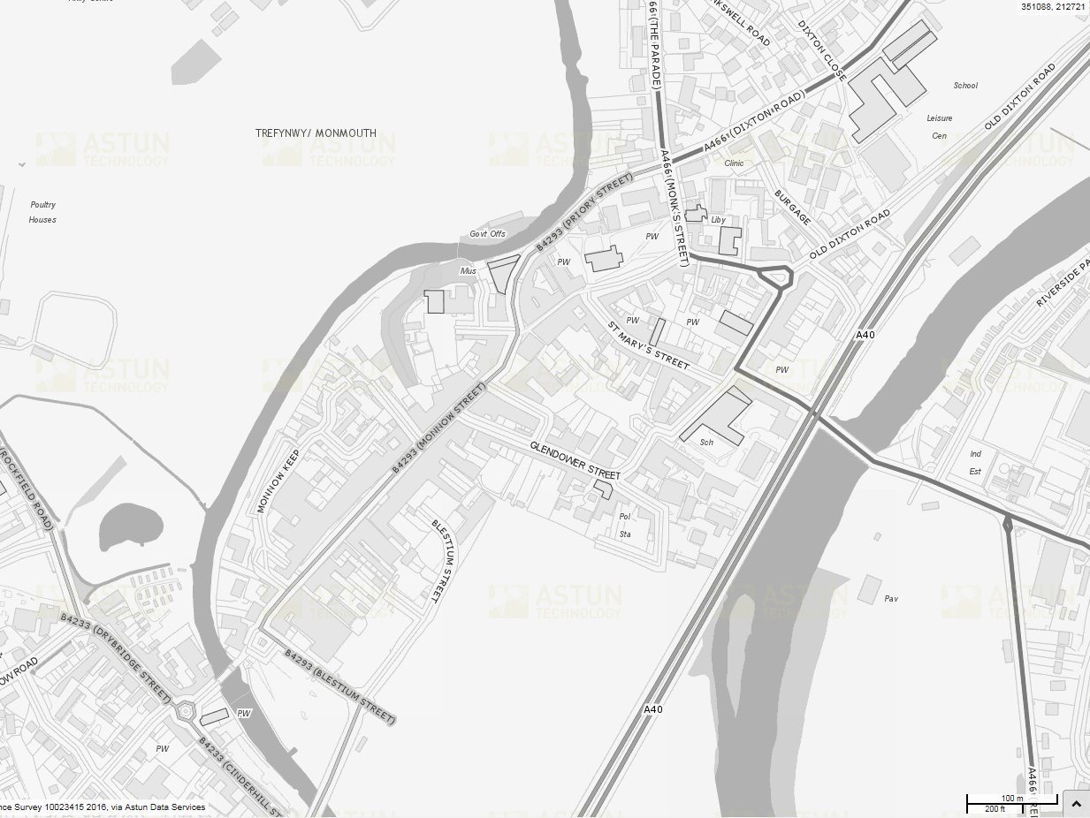
194
197
195
196
198
203
193
MONMOUTH
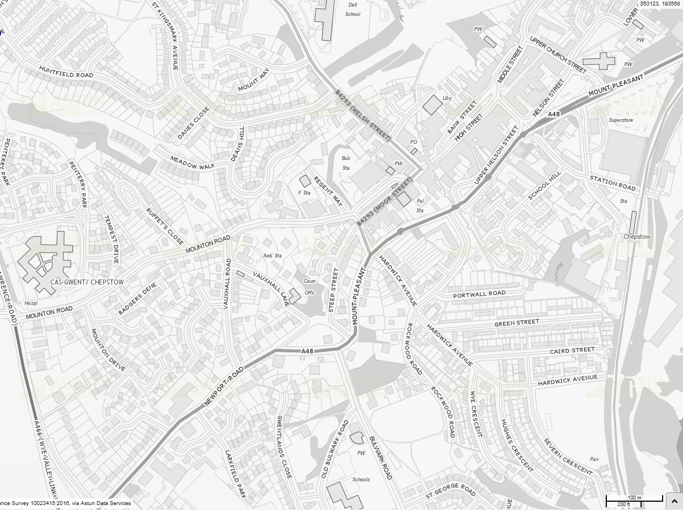
92
93
91
90
200
199
89
95
94
CHEPSTOW
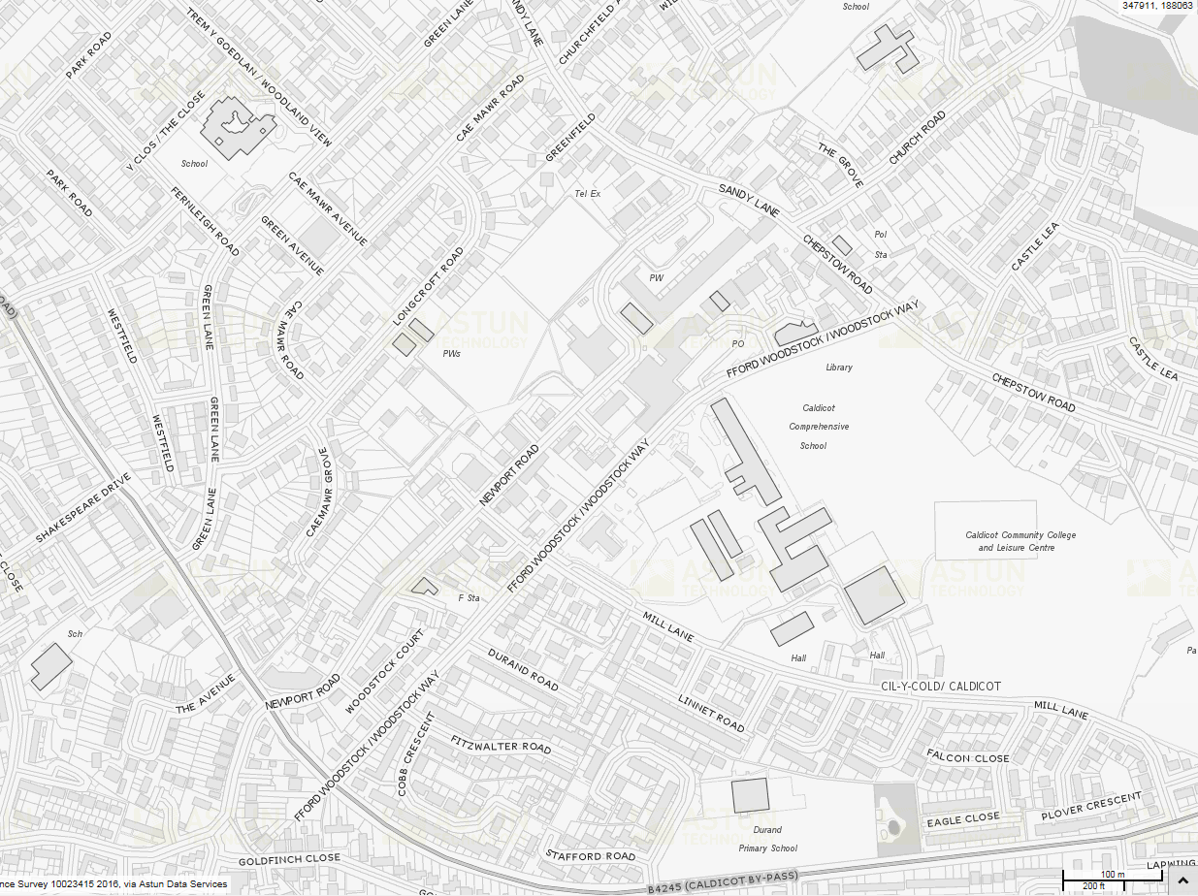
85
83
86
87
88
84
CALDICOT

Appendix 2

Monmouthshire County Council CCTV Scheme

Privacy Impact Assessment

CCTV can be privacy intrusive, as it is capable of putting many law abiding people under surveillance, recording their movements as they go about their day to day activities.
We must take into account what benefits are gained, whether other solutions exist, and what effect it may have on individuals.
These matters should be considered objectively as part of an assessment process on people’s privacy when considering the deployment of CCTV cameras.
We will use the results of the impact assessment to determine if CCTV is justified in all the circumstances and if so how should it be operated in practice.

Privacy Impact Assessment for CCTV Surveillance at: -

Address of Premises

What is your organisations purpose for using CCTV?

What are the problems it is meant to address?

Can CCTV technology realistically deliver these benefits?

Do you need images of identifiable individuals?

What are the views of those who will be under surveillance?

What could you do to minimise intrusion for those that may be monitored particularly if specific concerns have been raised?

Is the proposed camera deployment on a proper legal basis and operated in accordance with the law?

Is it necessary to address a pressing need, such as public safety, crime prevention or national security?

Is it justified in the circumstances?

Is it proportionate to the problem that it is designed to deal with?

Appendix 3
CCTV Control Room Reporting Data.
Abergav-enny | Camera Patrol | DVD Burned | Observation | Police Intervention | Storenet | Fault emailed / reported to AVA | Police viewed footage only | Grand Total
Apr | 53 |  | 24 | 36 | 21 |  |  | 134
May | 39 |  | 11 | 22 | 27 |  |  | 99
Jun | 48 | 4 | 11 | 28 | 22 | 1 |  | 114
Jul | 58 |  | 8 | 19 | 32 | 2 |  | 119
Aug | 61 |  | 17 | 24 | 11 | 1 |  | 114
Sep | 66 |  | 3 | 8 | 22 | 1 |  | 100
Oct | 65 |  | 8 | 19 | 29 |  |  | 121
Nov | 60 | 6 | 3 | 15 | 22 |  |  | 106
Dec | 61 | 2 | 13 | 9 | 14 |  |  | 99
Jan | 63 | 1 | 9 | 11 | 5 |  | 3 | 92
Feb | 62 |  | 5 | 3 | 22 |  | 3 | 95
Mar | 59 | 1 | 8 | 4 | 10 |  |  | 82
Total | 695 | 14 | 120 | 198 | 237 | 5 | 6 | 1275
Caldicot | Camera Patrol | DVD Burned | Observation | Police Intervention | Storenet | Fault emailed / reported to AVA | Police viewed footage only | Grand Total
Apr | 44 |  | 5 | 10 | 1 |  |  | 60
May | 36 | 2 |  | 3 |  | 1 |  | 42
Jun | 42 |  | 10 | 2 |  |  |  | 54
Jul | 50 | 2 | 1 | 6 |  | 1 |  | 60
Aug | 52 | 1 | 2 | 5 | 1 |  |  | 61
Sep | 67 | 1 | 4 | 8 |  |  |  | 80
Oct | 62 | 1 | 4 | 6 | 1 |  |  | 74
Nov | 58 |  |  | 3 |  | 2 |  | 63
Dec | 56 | 3 | 2 | 1 |  |  |  | 62
Jan | 59 | 2 | 1 | 2 |  |  | 1 | 65
Feb | 59 | 1 | 5 | 7 |  |  |  | 72
Mar | 55 |  | 5 | 1 |  | 1 |  | 62
Apr |  |  | 1 |  |  |  |  | 1
Total | 596 | 13 | 35 | 44 | 2 | 5 | 1 | 696
Chepstow | Camera Patrol | DVD Burned | Observation | Police Intervention | Storenet | Fault emailed / reported to AVA | Police viewed footage only | Grand Total
Apr | 52 | 2 | 19 | 20 | 1 |  |  | 94
May | 39 | 1 | 3 | 14 |  |  |  | 57
Jun | 47 |  | 8 | 11 |  |  |  | 66
Jul | 55 | 4 | 4 | 10 | 1 |  |  | 74
Aug | 61 | 1 | 10 | 9 |  |  |  | 81
Sep | 63 |  | 8 | 7 |  |  |  | 78
Oct | 67 |  | 6 | 2 |  |  |  | 75
Nov | 63 | 2 | 5 | 12 | 1 |  |  | 83
Dec | 63 | 3 | 17 | 20 |  |  |  | 103
Jan | 63 | 6 | 9 | 11 |  |  | 3 | 92
Feb | 61 |  | 9 | 10 |  |  | 1 | 81
Mar | 58 | 2 | 14 | 5 |  |  |  | 79
Total | 692 | 21 | 112 | 131 | 3 | 0 | 4 | 963
Monmouth | Camera Patrol | DVD Burned | Observation | Police Intervention | Storenet | Fault emailed / reported to AVA | Police viewed footage only | Grand Total
Apr | 75 | 2 | 3 | 8 | 2 |  |  | 90
May | 52 |  | 7 | 9 | 17 |  |  | 85
Jun | 54 | 2 | 11 | 16 | 14 |  |  | 97
Jul | 58 | 6 | 6 | 13 | 14 |  |  | 97
Aug | 56 | 2 | 7 | 19 | 1 | 1 |  | 86
Sep | 63 |  | 3 | 10 | 7 |  |  | 83
Oct | 66 |  | 6 | 11 | 13 |  |  | 96
Nov | 61 |  | 7 | 19 | 4 | 1 |  | 92
Dec | 58 |  | 2 | 11 |  |  |  | 71
Jan | 57 | 1 | 1 | 5 |  |  | 1 | 65
Feb | 56 | 1 | 3 | 1 |  |  |  | 61
Mar | 55 | 3 | 8 | 7 |  |  |  | 73
Total | 711 | 17 | 64 | 129 | 72 | 2 | 1 | 996
Grand Total | 2694 | 65 | 331 | 502 | 314 | 12 | 12 | 3930

Appendix 4

2015/16 Incident Count by Town
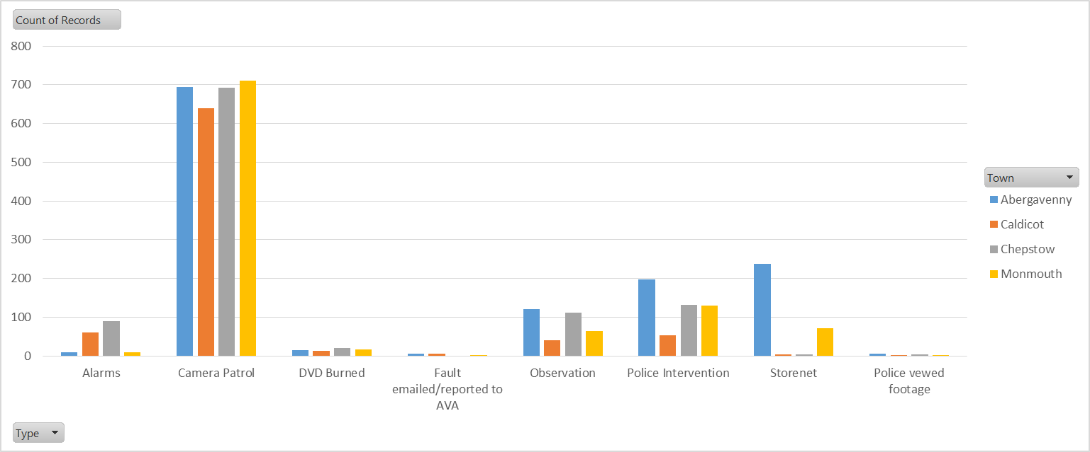

2015/16 Observation / Police Intervention Count per Month
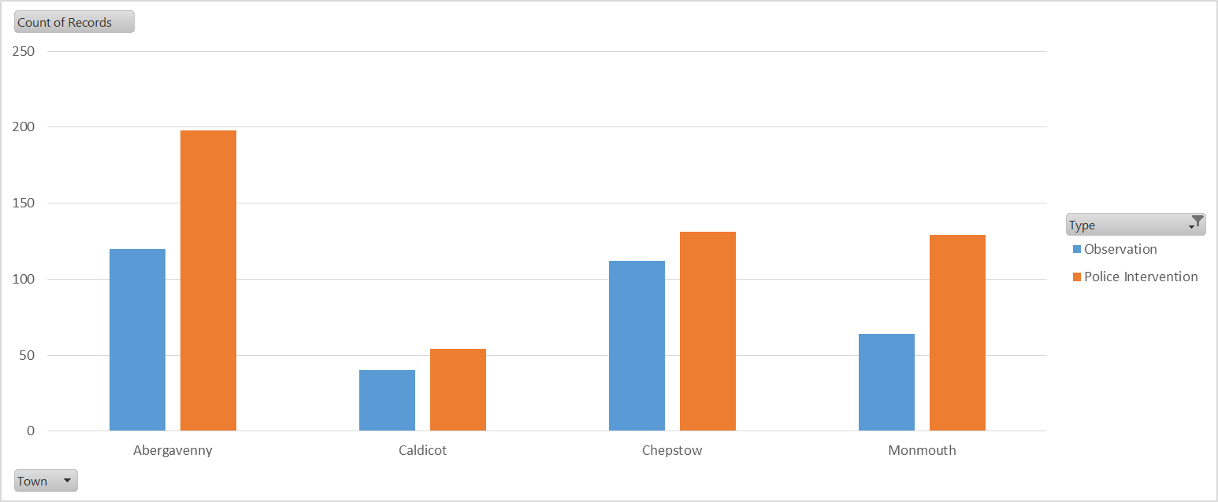

2015/16 Observation / Police Intervention Count per Month (Abergavenny)
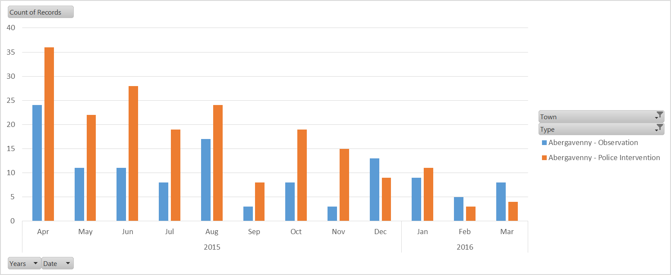
2015/16 Observation / Police Intervention Count per Month (Caldicot)
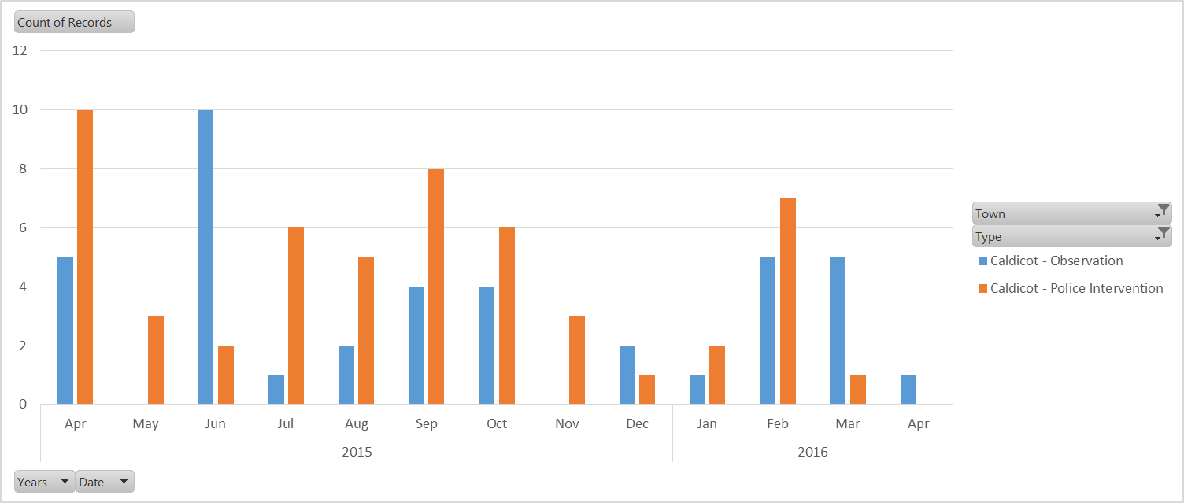

2015/16 Observation / Police Intervention Count per Month (Chepstow)
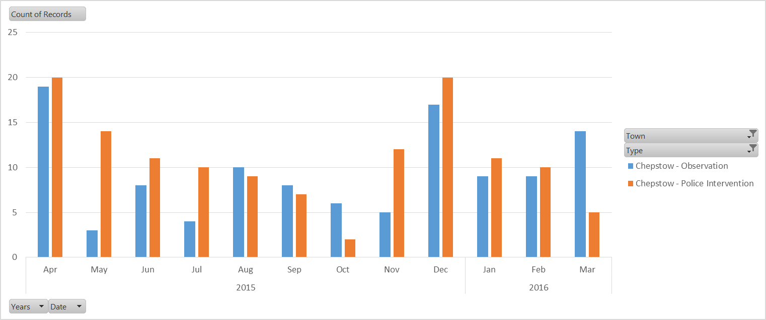

2015/16 Observation / Police Intervention Count per Month (Monmouth)
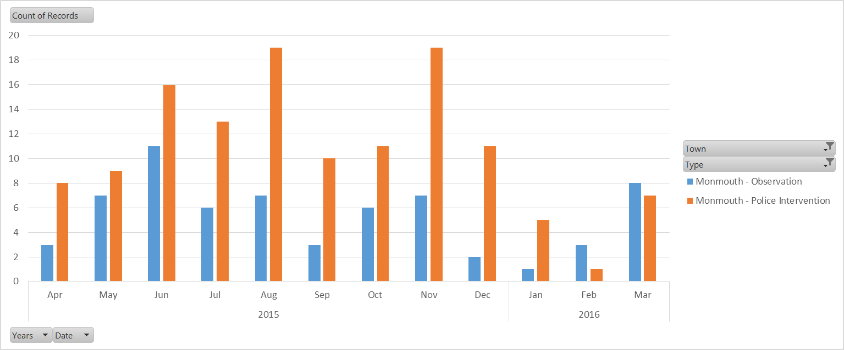

2015/16 Targeted CCTV Patrols
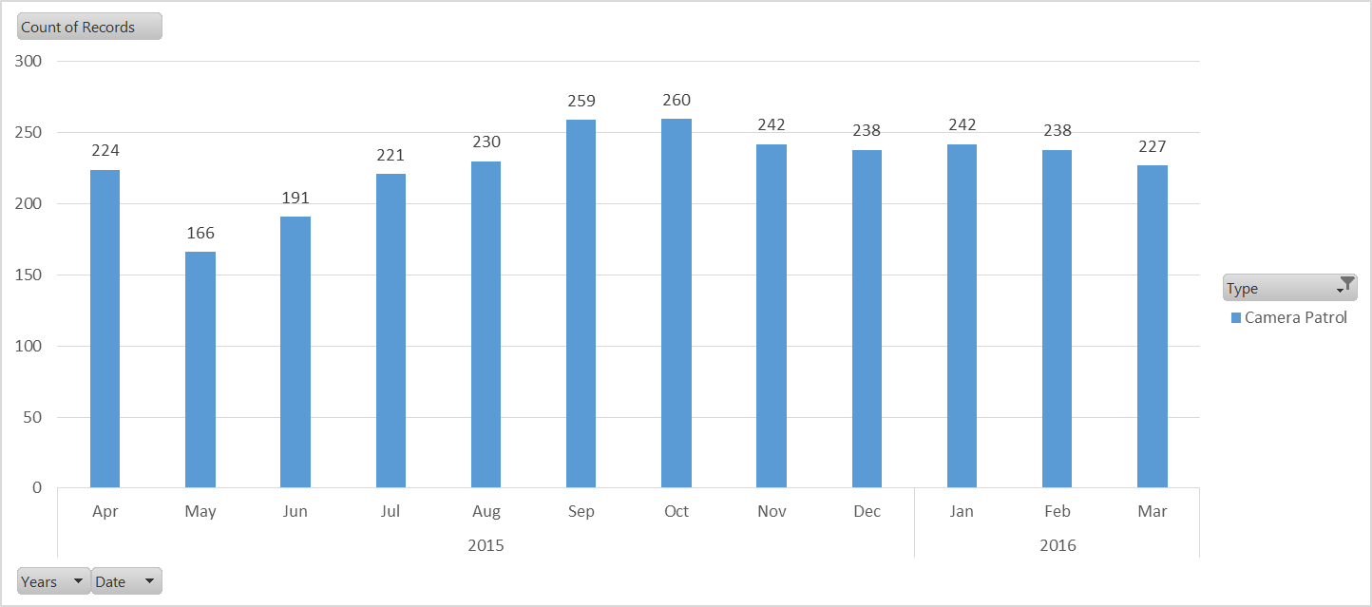

2015/16 DVDs Supplied to Police
